- News
- Middle East
- Ex-South Africa leader Jacob Zuma to face corruption charges
Charges announced by chief prosecutor against former president concern a $2.5bn arms deal made in the 1990s.
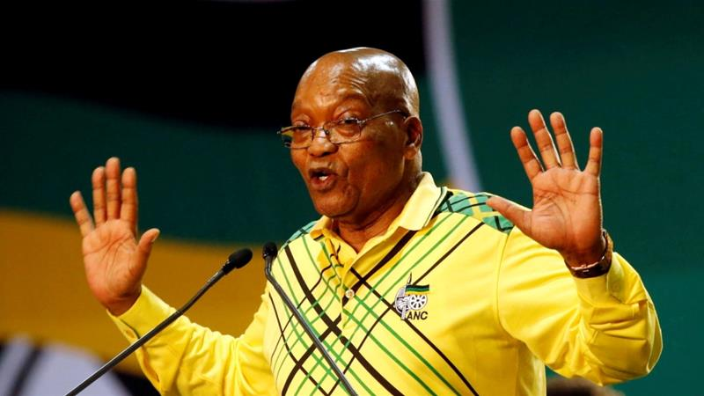 Zuma has faced corruption accusations before but maintains his innocence [Siphiwe Sibeko/Reuters]
South Africa’s, chief prosecutor has announced he will charge Jacob Zuma, the former president, with corruption related to an arms deal.
Zuma will face 16 charges, including racketeering, fraud and money laundering.
The corruption allegedly occurred during a $2.5bn deal made in the 1990s. Zuma was first charged with corruption in 2005 when his financial adviser was jailed on fraud and corruption charges.
"After consideration of the matter, I am of the view that there are reasonable prospects of successful prosecution of Mr. Zuma on the charges listed in the indictment," Shaun Abrahams, the chief prosecutor, said.
Abrahams said a trial is an appropriate place to settle the matter. The chief prosecutor thinks there are "reasonable prospects of a successful prosecution".
Zuma went to trial in, 2006 but the case stalled when the prosecution said it was unable to continue more than a year after he had been charged.
The case was controversially dropped by the National Prosecuting Authority in 2009, shortly before Zuma won the presidency.
Zuma was forced to resign in February by his ruling African National Congress (ANC) party.
He was accused of corruption numerous times during his nine-year presidency but has always maintained his innocence.
The ANC responded to the charges against Zuma by reminding South Africans that the former president should be considered innocent until proven guilty.
ANC secretary-general Ace Magashule said in a statement: "The ANC reaffirms its confidence in our country's criminal justice system and our respect for the independence of the judiciary. We equally affirm our commitment to the constitutionally enshrined principle of equality of all before the law."

